With the announcement of Live Publish for WordPress last week, I wanted to take a moment to highlight a couple of the features around how we handle images in WordPress. By creating a Featured Image in Microsoft Word, I will show how easy it is to use Word and Live Publish together to transform your content management experience. At the end of the article I will attach the Word document so you can see I’m not talking boloney .

The featured image
One of the more important things when it comes to a post or page is having a captivating image to advertise your post. Today I am going to use the built-in Word drawing tools to create this image. Since we can also just pick the first image in the document as the featured image, it does not matter where we put it.
To start off, I will find an open source image to use that is:
- really cool looking;
- really big; and
- the wrong shape.
The reason I want these constraints is that I want to demo a couple features for you:
- Our image optimisation,
- The ability to use cropped images from Word
- and that a road during a sunset looks cool .
This looks rather nice. Credit due here: Photo by KAUE FONSECA on Unsplash.
Exploring Live Publish
for WordPress
If you look at the original document you will see that I;
- Cropped the image to the size I need for the blog
- Added a text box for the text on the image
- Did some basic styling
The best part is that this is still all editable in the Word document and can just be re-published over if required.
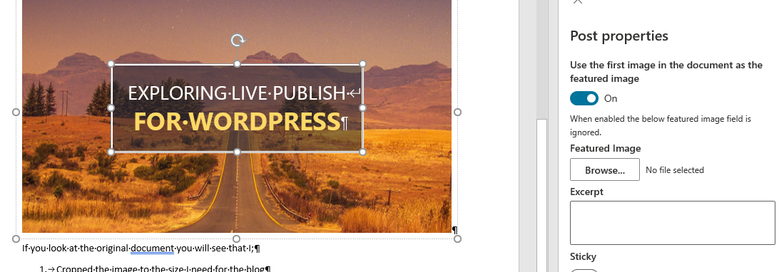

Conclusion
Creating quality, beautiful pages and posts in Live Publish really is as simple as using Microsoft Word and clicking save. You can build Featured Images quickly with relatively low design experience and just a bit of creativity . Check it out today on your own blog with the document below. What are you waiting for!!

